Needs to Improve:
Admin
- Reports
  - Generate reports on users, classes, and system statistics.
    - Error generator report. Hard to fetch
- User Management
  - View All Students
    - "Student details view coming soon”
- Audit Logs
  - View Audit Logs
    - Error loading audit logs: Failed to fetch
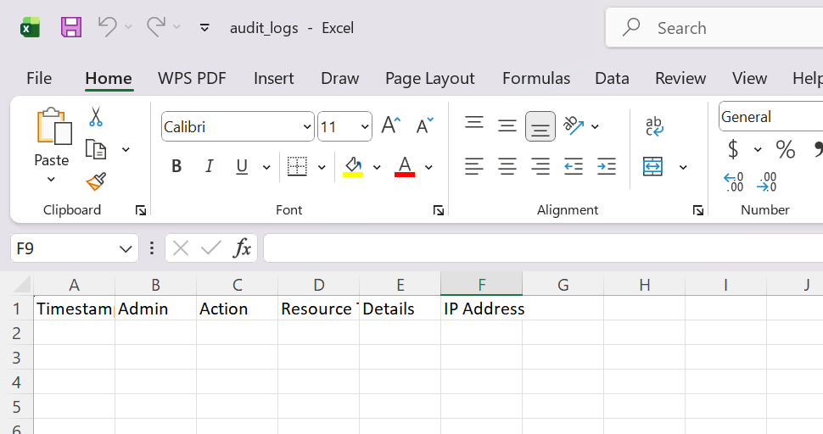
This part works.
- Create Instructor
    - It caused data breach on password
    - Couldn’t add the instructors

Instructor:
- Create Instructor
    - Add filters by: Section, Subject, Track, Year, Date Joined

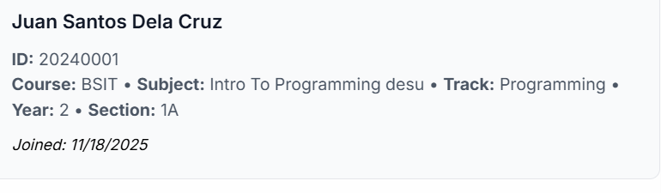
Should be:
Picture
Name:
ID No.:
Course:
Subject:
Track:
Year:
Section:

Date Joined:

- Add New Class
  - Error! Error saving class. I Recommended that the 1st error will be a symbol of warning.
- Grade Builder
  - Work on the sizes and Proportion of the grade, especially on the dashboard part, make it a little smaller.
  - Could add the slider to make it cleaner
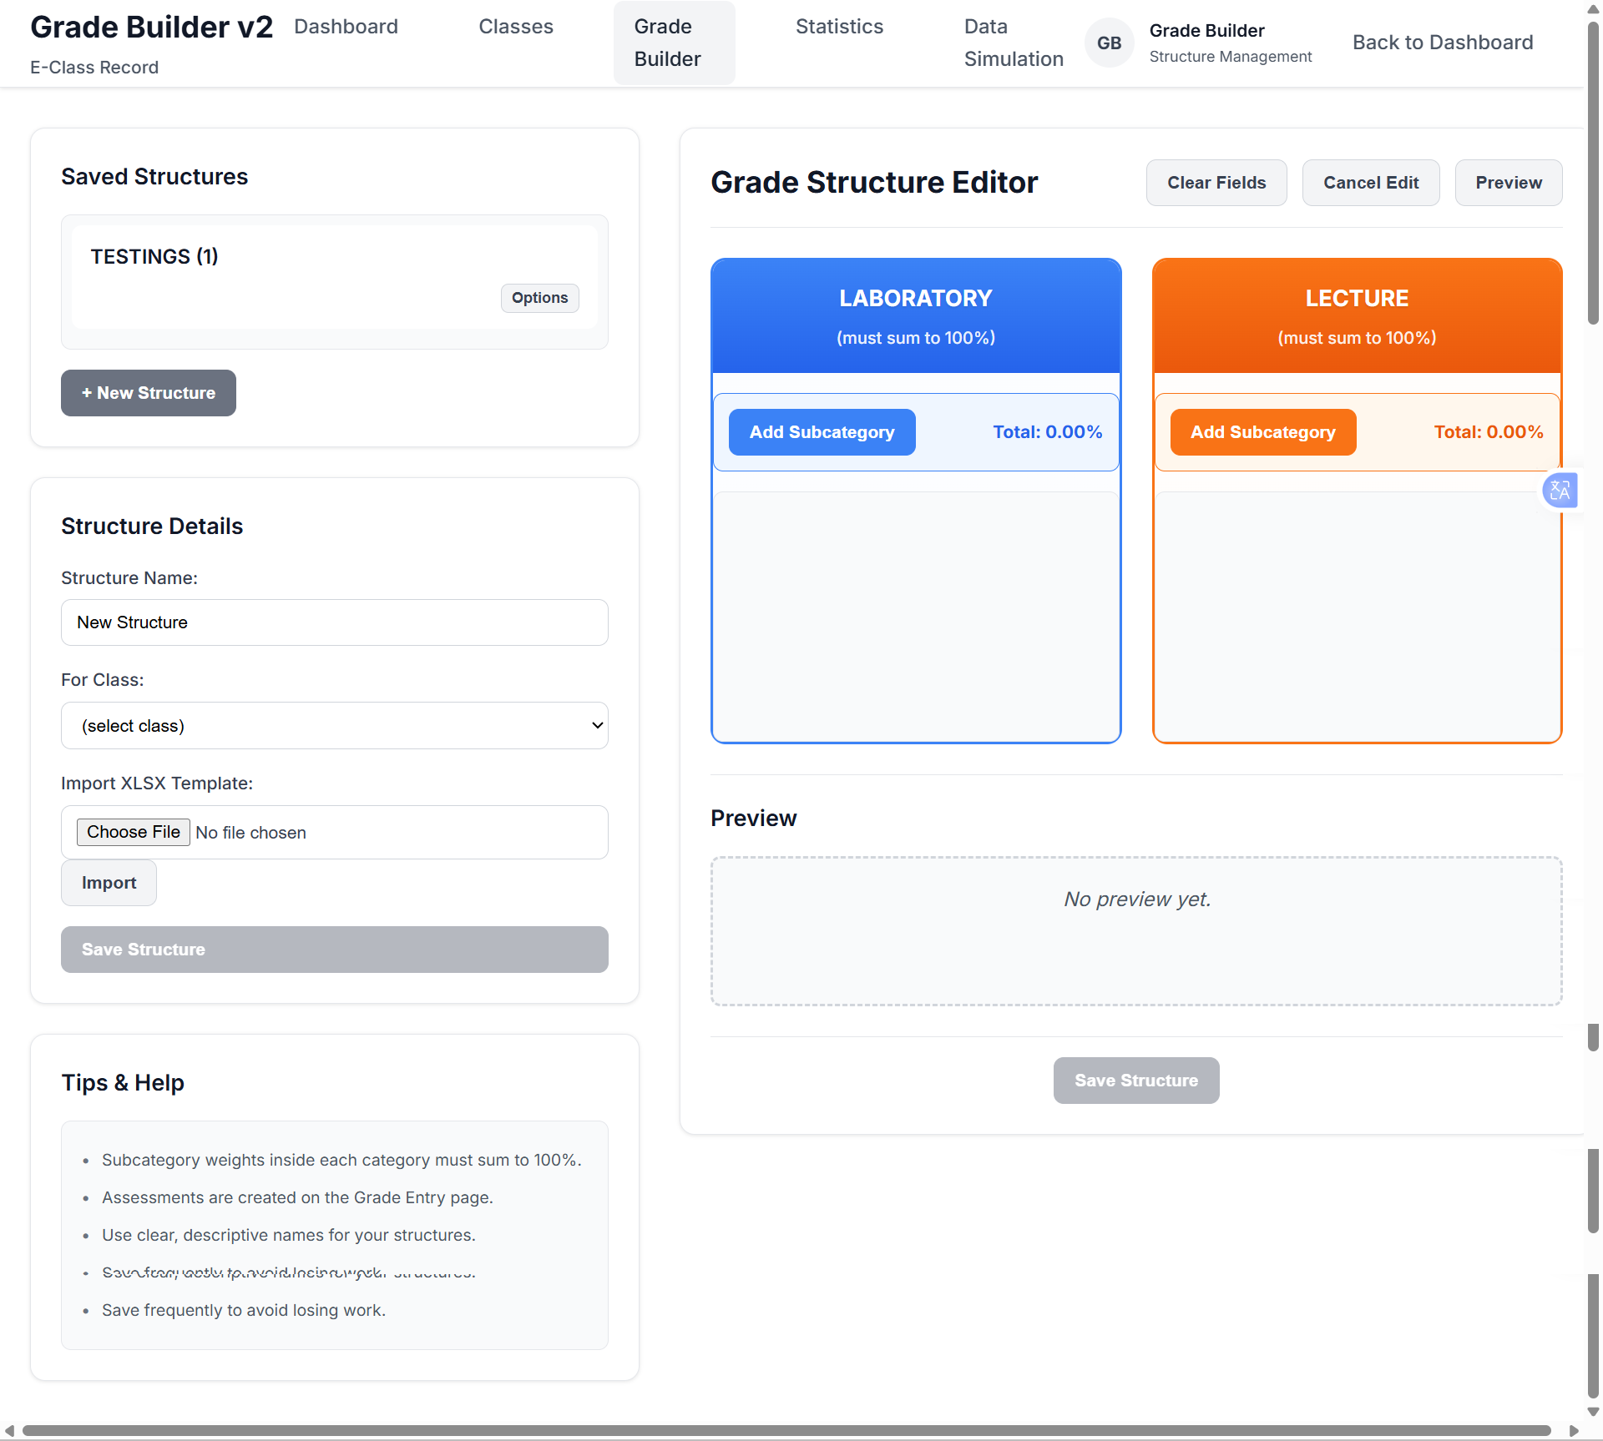

- Data Simulation
  - Work on the sizes and Proportion of the grade, especially on the dashboard part, make it a little smaller.

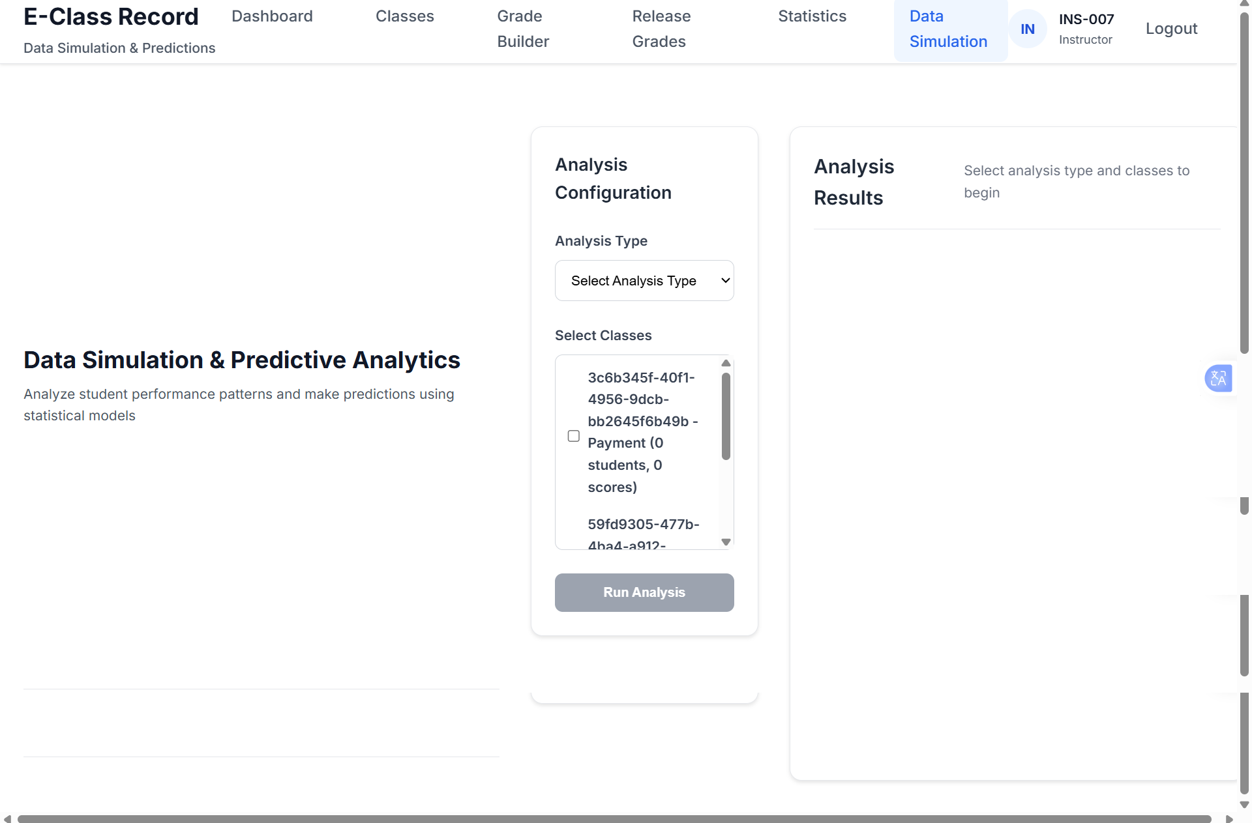

Students
- My Profile
  - Edit
    - Adjust the placement
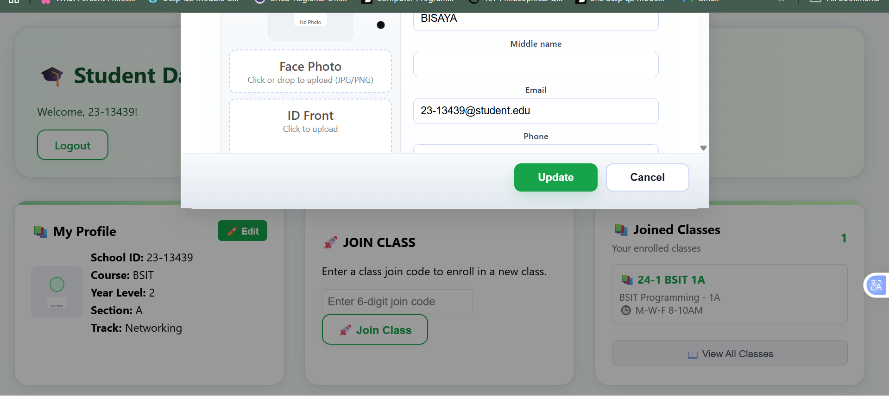
- Loading
    - Put in on the lowest part and adjust it
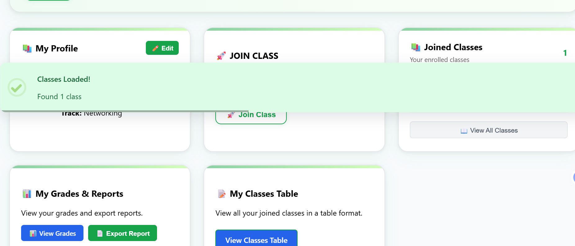
- Class Grades
    - Improve the Proportion. A lot of spaces
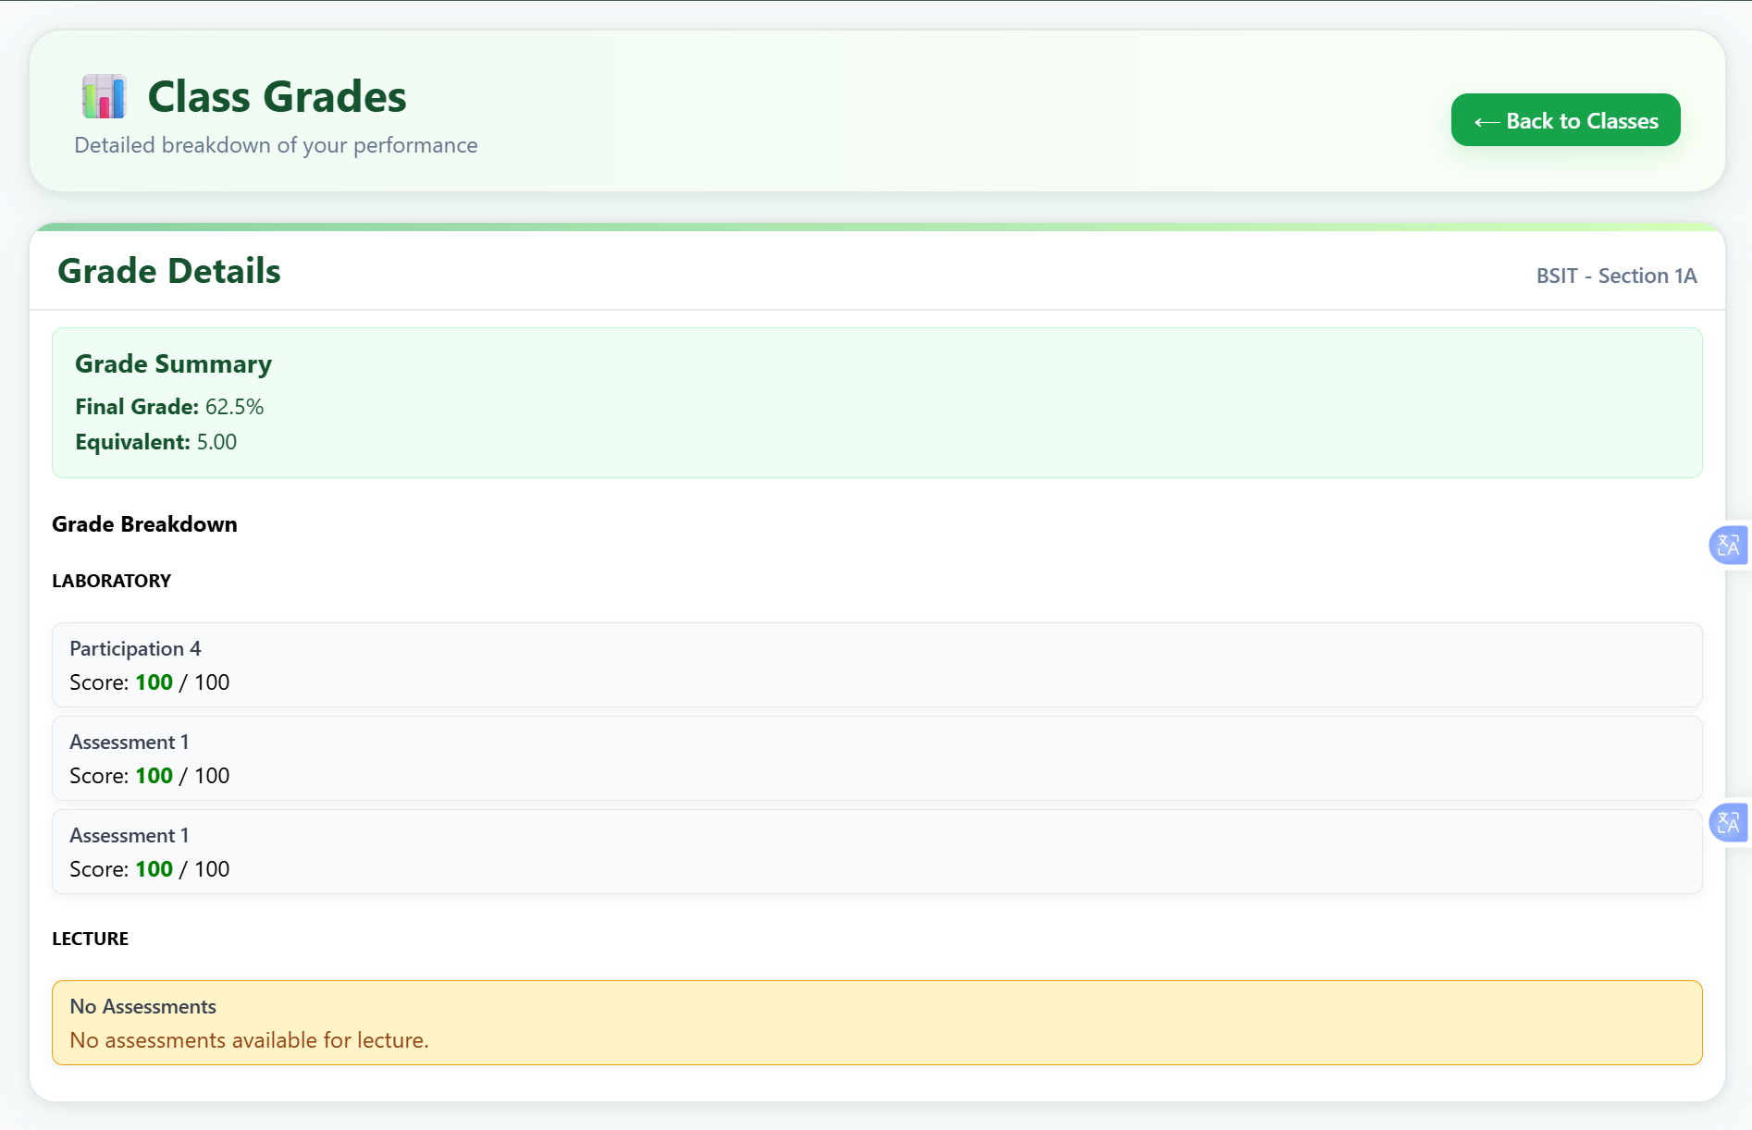
Lecture
Sub Category
Score
Percentage
Laboratory
Sub Category
Score
Percentage

